2025-2026 Annual Training Package

**5 FOCUS AREAS**



FOCUS AREA#1 – Safety Personal Protective Equipment

The importance of correct personal protective equipment (PPE) use in the logging industry cannot be overstated. A worker's last line of defence in case of an accident, **PPE can prevent or greatly reduce the chance of serious injury**. However, this can only be done if the worker commits to its use.

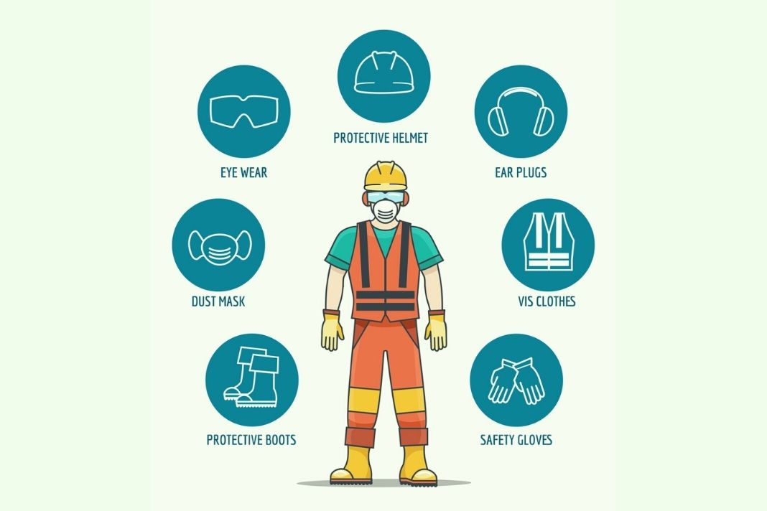

F OCUS AREA#2 Haul Channel radio procedures

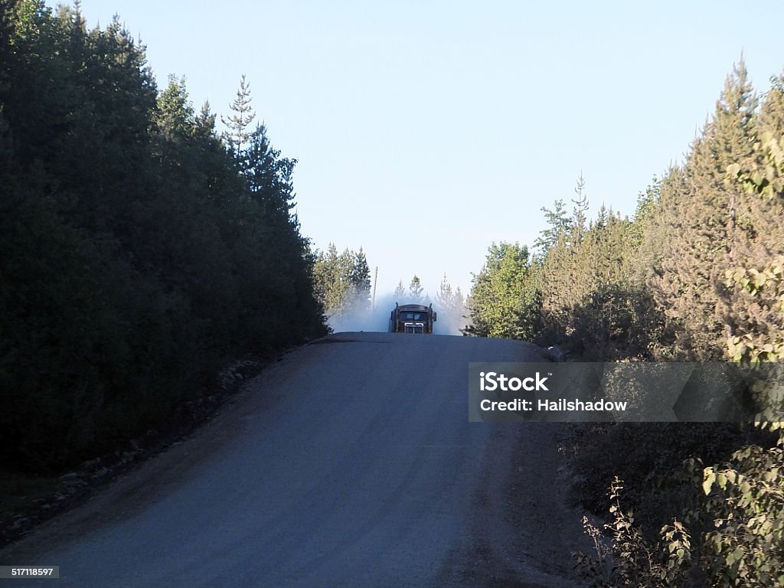

* All roads to have haul channel posted at start of road
* follow radio procedures on every road
* Ensure km signs are posted on every road before hauling commences.

FOCUS AREA#3 – Communications with Miisun

notify Miisun (Kurt/Johnathon)

* Start up notification – 5 days Prior to starting any operation – harvest, road construction, water crossings, renewal
* Suspended – if operations are leaving for more than 20 days, but will return
* Completed – when activity is done in the block

FOCUS AREA#4 –FIRE PREPARDNESS and awareness

* FiRE Training completed
* Fire cache on site and inspected prior to fir season
* Field guide to modifying industrial operations protoco

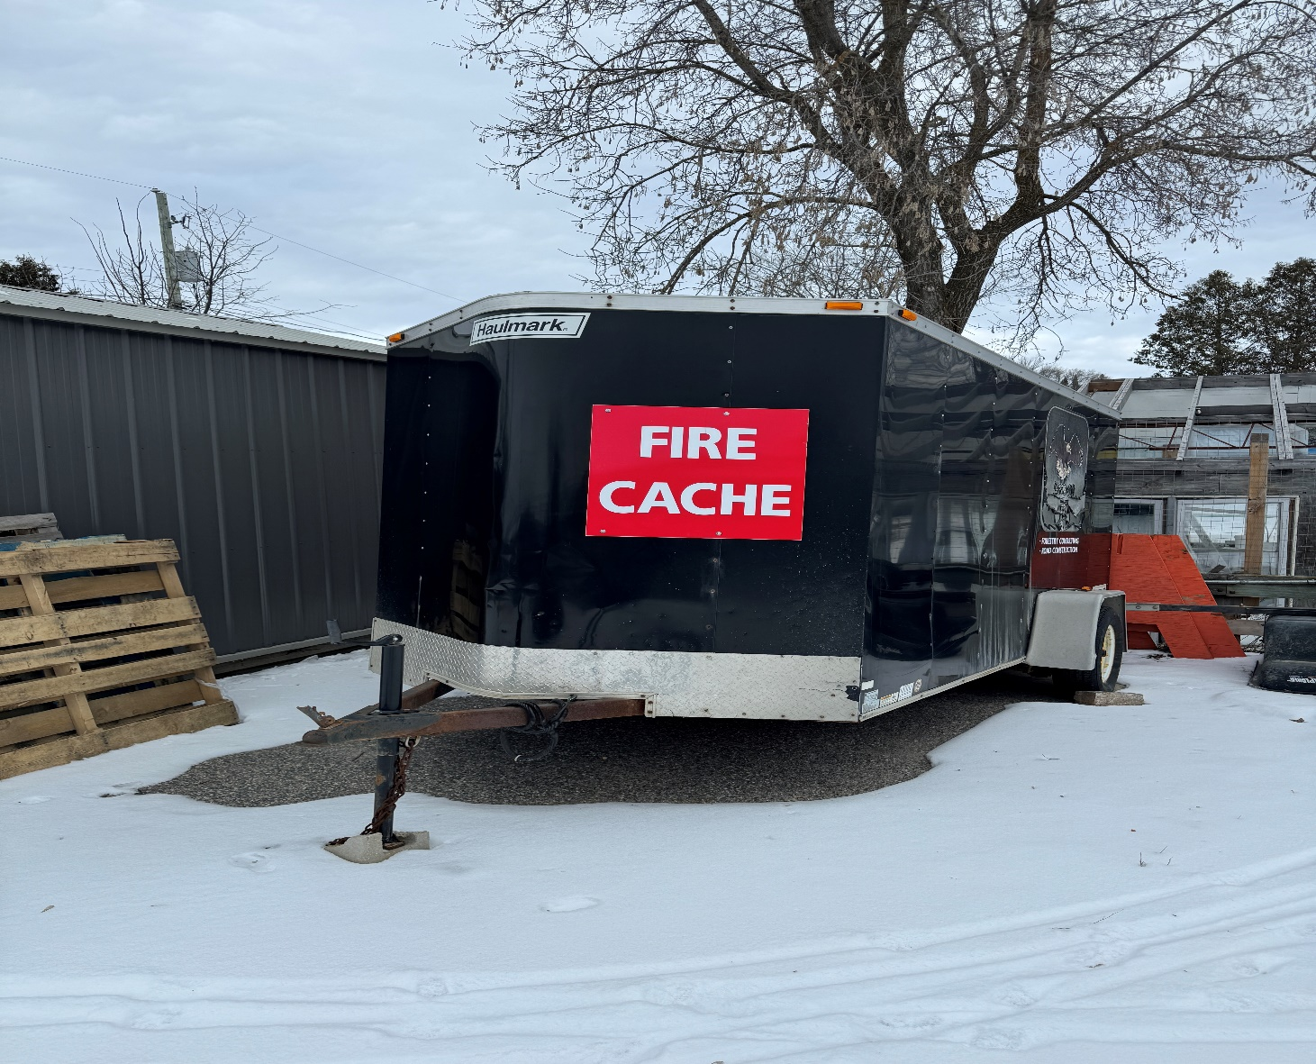

FOCUS AREA #5 Reduce ghg emissions where possible

* Limit idling where possible.
* Truck pooling where possible