2026-2027 Annual Training Package

5 FOCUS AREAS



FOCUS AREA#1 – Chipper debris Management
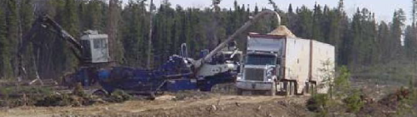
You can’t leave it at roadside >20cm thick (you’ll have to go back….
MAKE SURE BEFORE YOU LEAVE THE BLOCK THAT THESE AREAS HAVE BEEN MANAGED
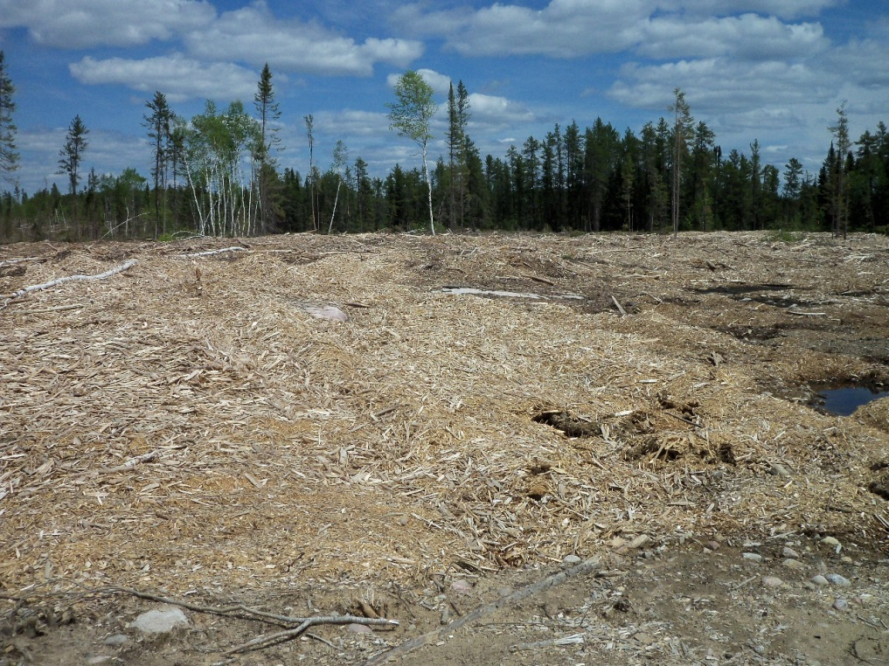

F OCUS AREA#2 wood utilization
- Strategies for tops are being developed with mnr
- Leave tops at roadside if returning for future wood
- Available for firewood
- Put in slash piles if not accessible, no market and not returning
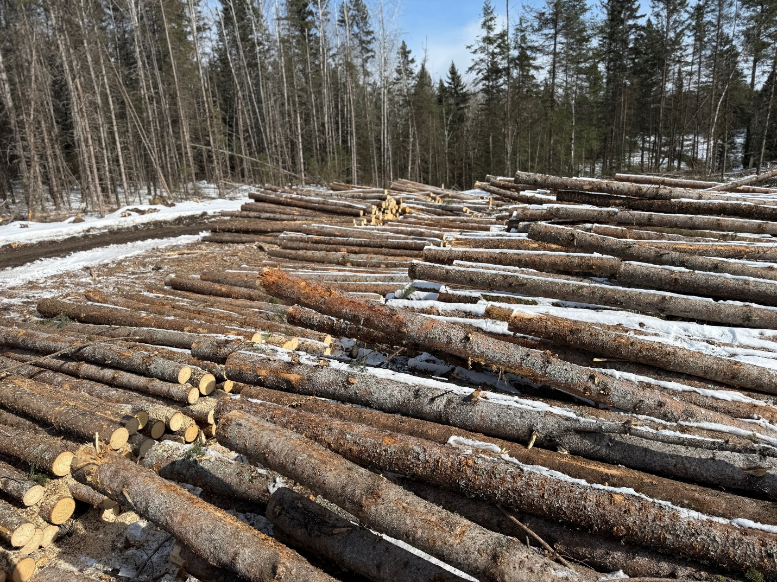

FOCUS AREA#3 – Communications with Miisun
notify Miisun (Kurt)
- Start up notification – 5 days Prior to starting any operation – harvest, road construction, water crossings, renewal
- Suspended – if operations are leaving for more than 20 days, but will return
- Completed – when activity is done in the block

FOCUS AREA#4 –FIRE PREPARDNESS and awareness
- FiRE Training completed
- Fire cache on site and inspected prior to fir season
- Field guide to modifying industrial operations protocol
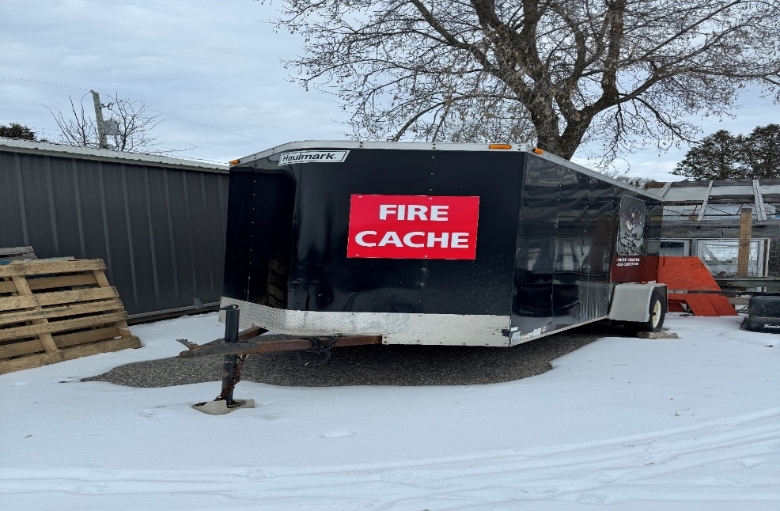
FOCUS AREA #5 Reduce ghg emissions where possible
- Limit idling where possible.
- Truck pooling where possible
- Maintenance concentrated – multiple logging operation utilizing same road system

