Invasive Species Index Card 2026-2027
KENORA FOREST

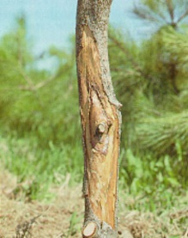  `  Scleroderris  Canker  Fungal Disease  Features: Scleroderris canker is a disease cause by fungal infection under moist conditions. Peak period for infection is June and July when the fungus infects wounded buds, shoots and needles. The infection stars at tip of the branch and grows down the stem where a canker may be formed. Fungus is dormant in winter.  Habitat: Found in pine and spruce trees. Sign of infection include brown or orange discolored needles in spring, dead branches, green stain beneath bark and/or canker on infected stems.  Photo Credit: Gremmeniella abietina (Scleroderris Canker) - Fact Sheet - Canadian Food Inspection Agency (canada.ca) | 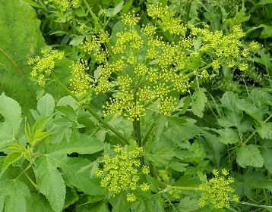  Features: Wild parsnip grows, 0.5m to 1.5m tall, has a single light green stem that sometimes has a purple tinge. The stem is smooth, deeply-grooved and hollow at about 2.5cm to 5cm in diameter. Leaves alternative on stem, are saw-toothed edges and 15cm in length. Leaves are divided into leaflets, with 2 to 5 pairs of opposite leaflets. Flowers are 5 yellow petalled clusters that show June to October. Plant sap can cause rashes, burns or blisters to skin.  Habitat: Found in fields, disturbed habitats such as roadsides and railroad embankments. Spread due to transfer of plant parts in earth material or on equipment.  Photo Credit: Wild Parsnip – Profile and Resources | Invasive Species Centre  Land Plant  Wild Parsnip | 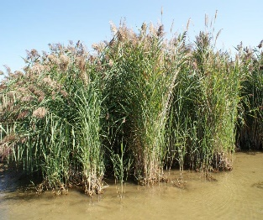  Photo Credit: https://www.ontarioinvasiveplants.ca/invasive-plants/species/phragmites/  Features: Phragmites is a perennial wetland grass with a rigid but hollow stem, growing up to 5m tall. Seedheads start out purplish-brown, then get fluffier and turn a while to tan color. Leaves are alternate, flat and taper to a point.  Similar to native species; invasive species will be in almost monoculture stands and very dense, with up to 200 stems.  Habitat: Found in wet or low-lying areas such as roadside ditches, wetlands, wet fields, shorelines. Can be found in dry areas adjacent to wet areas due to extensive root system. Spread due to transfer of plant parts in earth material or on equipment.  European Common Reed (Phragmites)  Aquatic Plant
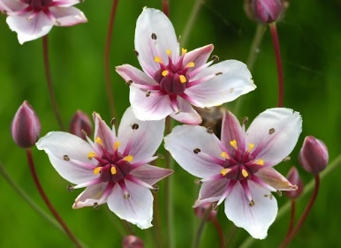  Features: Flowering rush has 20 to 25 pink flowers that grow in a cluster like an umbrella. Flowers emerge early summer to mid fall. The plant can reach up to 2m in height and resembles a large sedge. Leaves are triangular in cross-section; narrows and spirals towards the tip.  Habitat: Emergent plant found in shallow waters – shorelines, wetlands, ditches, lakes and rivers – and deeper waters 3m to 6m deep as a submergent non-flowering plant. Full sun conditions in a variety of soil types. Spread due to transfer of plant parts in earth material or on equipment.  Photo Credit: Flowering Rush | Ontario's Invading Species Awareness Program  Flowering  Rush  Aquatic Plant | 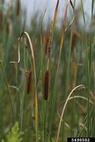  Narrow-leaved Cattail  Aquatic Plant  Features: Narrow-leaved cattails are perennials plants that grow up to 3m tall. Plant has flowering stalk with 4 or more leaves. Very narrow green leaves are pointed, smooth, stiff and slightly twisted; 0.5cm to 1cm wide and 0.5m to 2m long. Similar to native species; invasive species will have a gap between the two parts of the flower stalk. Can form dense monoculture stands.  Habitat: Found in wet areas with sun. Spread due to transfer of plant parts in earth material or on equipment.  Photo Credit: narrow-leaved cattail, Typha angustifolia Typhales: Typhaceae - EDDMapS | 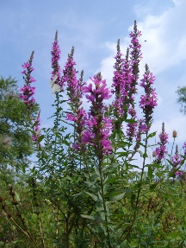  Purple  Loosestrife  Aquatic Plant  Photo Credit: Purple Loosestrife - Ontario Invasive Plant Council (ontarioinvasiveplants.ca)  Features: Purple loosestrife is a very hardy perennial plant. Mature individuals can have more than thirty flowering stems which can produce up to 2.7 million seeds annually. Each flower spike is made up of many individual flowers. Individual flowers are small and have five or six pink-purple petals surrounding small, yellow centers.  Habitat: Found in moist habitats, wetlands, marshes, wet meadows, flood-plains, damp roadside ditches. Prefers disturbed areas with full sun. Spread due to transfer of plant parts in earth material or on equipment and naturally by wind, water and wildlife.
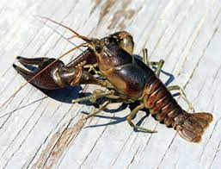  Features: Rusty crayfish are aggressive and large, reaching 7.5cm to 13cm in body length, with rust-colored patches on the sides of the gray/green to red/brown bodies. Claws are same color as body with black bands near the tips. Head is smooth, pinched and concave. Invasive crayfish have an oval space between closed claws, whiles native crayfish do not.  Habitat: Commonly found in lakes, rivers, ponds and streams with clay, silts and gravel bottoms where rocks, logs or debris are present to hide under. Spread likely due to release of individuals used as bait.  Aquatic Invertebrate  Rusty  Crayfish  Photo Credit: Rusty crayfish | ontario.ca | 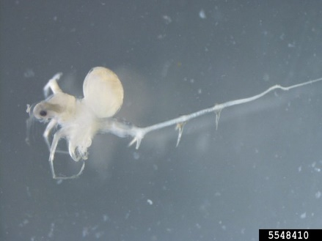  Photo Credit: Spiny Waterflea – Invasive Species Centre  Spiny  Waterflea  Aquatic Invertebrate  Features: Tiny, freshwater crustacean. Defined head with a large, black eye. Four pairs of legs; long, thin barbed (3 to 4 barbs) tail on abdomen. Adult bodies measure 1.5mm to 5mm in length; tails can be 7mm long.  Habitat: Large, deep, clear lakes with low summer bottom temperatures. Spread by transfer of infected water or fish from infected waterbody. | 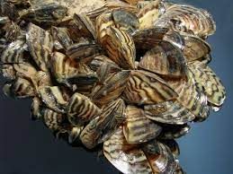  Features: Zebra mussel are triangular in shape, black or brown with white to yellow zigzagged patterns and averages 2cm to 4cm long. The color and patterns can vary. They sit flat on their underside.  Habitat: Zebra mussel are found in freshwater and are typically attached to objects, surfaces or other mussels. Spread by transfer of larvae and adults that are attached to equipment from an infected waterbody.  Photo Credit: Zebra and Quagga Mussels | Ontario's Invading Species Awareness Program  Zebra Mussel  Aquatic Invertebrate
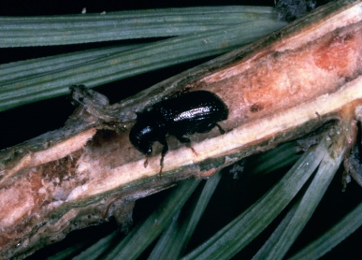  Insect  Pine Shoot  Beetle  Photo Credit: Pine Shoot Beetle – Profile and Resource | Invasive Species Centre  Features: Pine Shoot Beetle adults are small, black, cylindrical shaped ranging 3mm to 5mm long. Larvae are white with brown heads about 5mm long. Females bore up to 25cm tunnels into the inner bark and outer sapwood to lay eggs. Adults and larvae feed on host trees causing significant damage or death.  Habitat: Scots pine however all pine trees are susceptible. Where in infestations are abundant, fir, spruce and larch can be affected. Signs of damage include resin secretion at point of entry, sawdust on surface of tree, larval tunnels under bark, holes 2mm in diameter, reddish-yellow shoots or fallen dead shoots. | 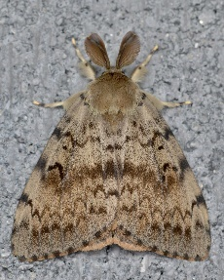  Photo Credit: Lymantria dispar – Profile and Resource | Invasive Species Centre  Features: Spongy moth are formerly known as Gypsy moth. Males are brown and winged with feathery antennae. Females are beige and cannot fly. Adults do not have mouthparts thus only live for two weeks to mate and lay eggs before dying. Larvae are 6cm long, covered with hairs, have five pairs of blue dots and six pairs of red dots running down the back. Eggs are tanned yellow covered with a fuzz.  Habitat: Primarily hardwood trees (oak, maple, birch, alder) but may feed on softwood trees. Signs of infestation include egg masses on bark, holes in leaves or completely defoliated trees.  Spongy Moth  Insect | 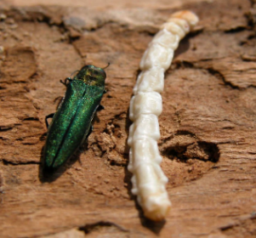  Emerald  Ash Borer  Insect  Photo Credit: https://www.ontario.ca/page/emerald-ash-borer  Features: Emerald Ash Borer are beetle/insects. Adults are bright metallic green, 8mm to 14mm long and 3mm wide. They have an elongated body and flat head. There is bright red color on their back underneath the wings.  Larvae are white, 25mm to 32mm long with a 10-segmented abdomen and have a brown head.  Habitat: Ash trees. Signs of damage within 2 years of infection and include crown dieback, bark deformities, D-shaped exit holes in tree, vertical cracks in trunk, yellowing of foliage. Spread by firewood transfer and non-heat treated ash lumber.
** To mitigate spread of invasive species, it is important to clean, drain, and dry all equipment before transport and site relocation.
REPORT ANY SIGHTINGS OF THESE SPECIES TO YOUR SUPERVISOR

