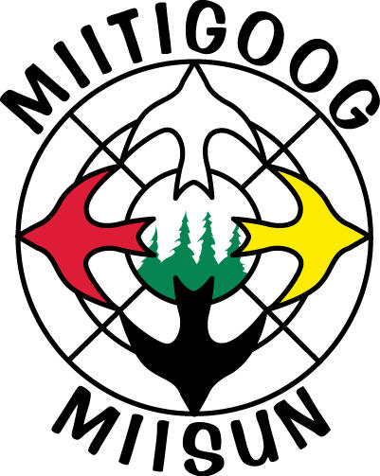 | ENVIRONMENTAL AND SUSTAINABLE FOREST MANAGEMENT POLICY

Miitigoog L.P. is committed to sustainable forest management practices and to being responsible stewards of the environment.
We are committed to independent certification of our forest management activities and to meeting the objectives and principles of the SUSTAINABLE FORESTRY INITIATIVE®
Miitigoog will:
1) Promote responsible forestry
2) Harvest at sustainable rates
3) Protect forest from damaging agents/pests
4) Reforest harvested areas promptly
5) Maintain long-term forest and soil productivity
6) Protect water bodies and riparian zones
7) Protect threatened and endangered species
8) Identify special sites and manage for them
9) Comply with environmental and social laws
10) Implement competent training programs
11) Continuous improvement
12) Monitor, measure, and report performance

