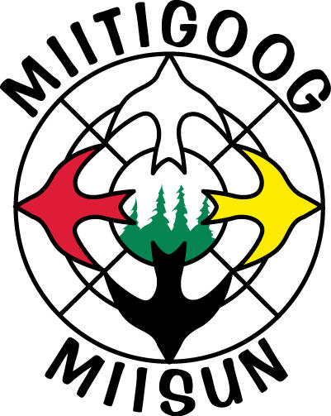 | HEALTH AND SAFETY POLICY

Miitigoog L.P. is committed to the health and safety of all employees and workers who work in support of forest management practices on the Kenora SFL. It is the policy of Miitigoog to ensure that its shareholders, contractors and licensee’s working on the Kenora SFL provide a safe and healthy work environment for themselves and their employees.

It is the expectation of Miitigoog that all employees, contractors, supervisors and licensees must be dedicated to the continuing objective of reducing the risk of injury in the workplace

