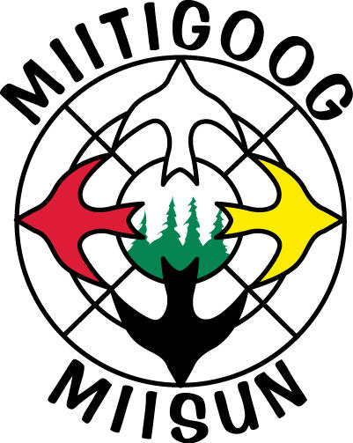 | SOCIAL RESPONSIBILITY POLICY

Miitigoog L.P. is committed to complying with all social laws and regulations. Specifically,

- Fair Working Conditions: We adhere to employment laws in Ontario and Canada. This includes hours of labor, minimum working age, workers compensation, and freedom from discrimination or workplace harassment.
- Freedom of Engagement: We prohibit the use of chattel slaves, forced labor, bonded laborers or coerced prison labor.
- Freedom of Association: We respect the right of employees to choose to organize and bargain collectively.
- Relationships with First Nations: We respect indigenous cultures and work cooperatively with their governenments. Miitigoog itself is a partnership with First Nations. The forest management activities on the Kenora SFL are administered by Miisun Integrated Resource Management Inc., which is a 100% First Nations owned business enterprise.
- Human Rights: We respect the basic standards of treatment to which all people are entitled, regardless of nationality, race, gender, or economic status.
- Freedom of Information: We provide all information to the public as required through assignment of the Kenora SFL to our business. We respect the right of the public to know how their resource is being managed on a sustainable basis.

