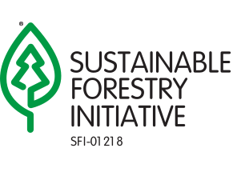 For a complete listing of Species at Risk in Ontario, please refer to: https://www.ontario.ca/page/species-risk-ontario
KENORA FOREST
ENDANGERED

SPECIES AT RISK INDEX CARD 2026-2027
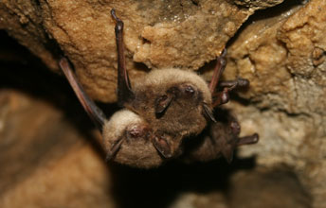  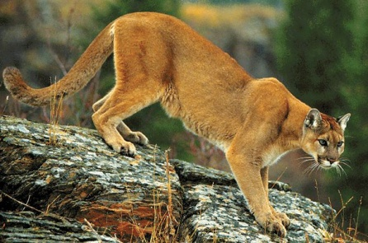  SPECIAL  CONCERN  Eastern  Cougar  Features: Eastern Cougar up to 2.5m long including tail, dens in rocky areas, footprint is 8cm wide with 4 toes and no claws showing  Features: Little brown bats have glossy brown fur and usually weigh between four and 11 grams. They are typically four or five centimetres long, with a wingspan of 22 to 27 centimetres. Little brown bats look similar to northern long-eared bats. They can be distinguished by the fleshy projection that covers the entrance to the ear. In little brown bats, the projection is long and thin, but rounded at the tip | 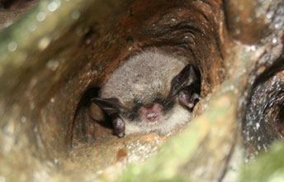  Features: Northern long-eared bats have dull yellow-brown fur with pale grey bellies. They are typically about eight centimetres long, with a wingspan of about 25 centimetres. Northern long-eared bats usually weigh between six and nine grams – a little more than a Canadian loonie or toonie.  Northern Myotis  ENDANGERED | 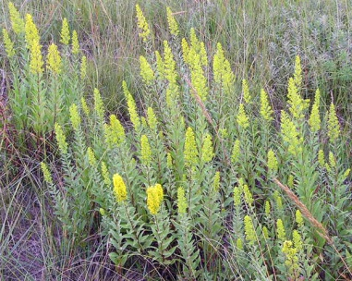  Features: Showy Goldenrod produce showy, yellow flowers in late summer and early fall. It grows in sunny areas.  Showy  Goldenrod  THREATENED
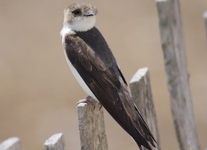  Features: The smallest swallow in North America. All adults appear similarly brown above and white from the chin to the under-tail. This small brown and white bird nests in colonies sometimes numbering in the thousands. Wherever there are steep walls in sand, dirt, or gravel, the Bank Swallow digs a tunnel for its nest with its small feet and bill.  Bank Swallow  THREATENED | ENDANGERED  Little Brown  Myotis | 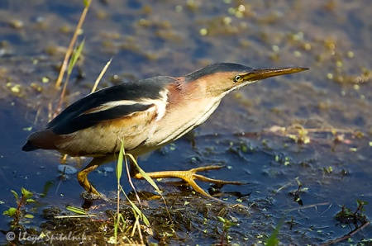  Features: The Least Bittern is more likely heard than seen, as it "coo"s softly from deep in a cattail marsh. This species is the smallest of the North American herons and is distinguished by chestnut patches on its' wings. Males darker than females  Least Bittern  THREATENED
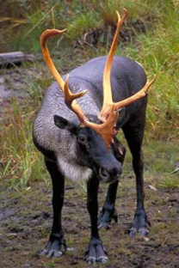  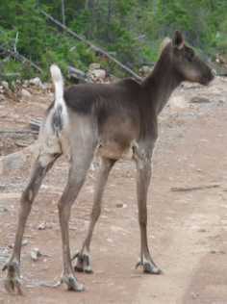  Features: Smaller than a moose, bigger than a deer. Grey, or brown-grey with white below. Lives in open bogs and open coniferous (mainly pine) forests, grows antlers.  Woodland  Caribou  THREATENED | 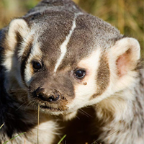  Features: The American Badger is gray, with dark legs and bold black and white stripes on its head and face. Badgers are built for digging.  American Badger  ENDANGERED | 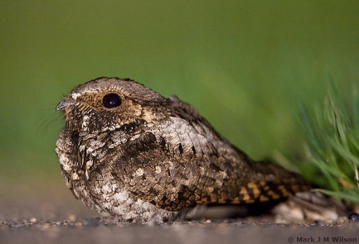  Features: The Whip-poor-will is a medium-sized bird, 22-26 centimetres long with brown and grey feathers. Since it becomes active at dusk, it is more commonly heard than seen. They are most vocal at nights when they sing their name “Whip-poor-will” often in long, seemingly endless series.  Whip-poor-will  THREATENED
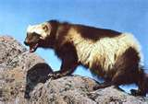  Features: Wolverine is about the size of a domestic dog, has bear-like paws with claws and a robust body. It has long dark brown fur, ears tipped with grey, and pale golden-brown stripes running along the sides of the body.  Wolverine  THREATENED | 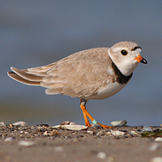  Features: The Piping Plover is a small shorebird that is well-camouflaged on the pale sand beaches it favours. Its stubby bill is orange with a black tip and its legs are bright orange. Its belly is white but the back, wings and most of the tail are the colour of dry sand. Adults have a bold black breast band and a smaller black band above their white forehead.  Piping Plover  ENDANGERED | 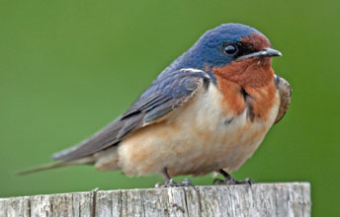  SPECIAL  CONCERN  Barn Swallow  Features: The Barn Swallow is a medium-sized songbird (about 15 to 18 centimetres long). Males have a glossy steel-blue back and upper wings, a rusty-red forehead and throat, a short bill and a broad blue breast band above its tawny underbelly
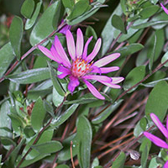  Western Silvery Aster  ENDANGERED  Features: The Western silvery aster is a perennial wildflower native to Ontario. It is most noticeable in the fall when it flowers. The stalks can grow up to 70 cm, with leaves that are covered in fine hairs (hence the silver appearance). Flowers are pink or pale purple and become redder as they age. | 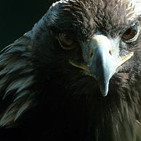  Features: The Golden Eagle is one of Ontario’s largest and most powerful birds of prey. The species is named for the golden-brown feathers on the back of its neck, head and upper wings, but the rest of the body is mostly dark brown.  Golden Eagle  ENDANGERED | 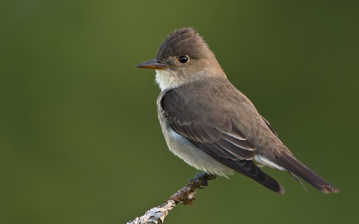  Features: Olive-sided Flycatcher is a medium-sized songbird approximately 18-20 cm long, with feathers along its sides and back a deep brownish, olive-gray colour against a white front. They are often seen perching at the top of tall trees. They have a loud, three-note whistle that sounds like “quick, three beers.”  Olive-sided  Flycatcher  SPECIAL  CONCERN
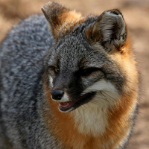  Features: The Grey Fox is the size of a small dog and looks very similar to the familiar Red Fox. But unlike the Red Fox, the Grey Fox has grizzled grey fur with lighter cinnamon coloured patches on its body. It also has a black tail tip, while the Red Fox has a white tail tip. The Grey Fox has shorter legs and a smaller snout than the Red Fox, and it can have a very long bushy tail.  Grey Fox  THREATENED | 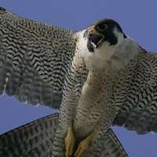  Features: The Peregrine Falcon is a crow-sized bird with a slate blue back and a cream-coloured chest covered in dark markings. Peregrine Falcons have pointed wings that span about one metre, a narrow tail and adults have a prominent black “moustache.” The dark feathers on the falcon’s head make the bird look like it’s wearing a helmet.  Peregrine Falcon  SPECIAL  CONCERN | 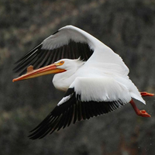  Features: The American White Pelican is a very large bird weighing about 6-7 kg, with white feathers and black wing tips. It has a large orange-yellow bill and pouch, a short, stout tail, webbed feet and a wingspan of up to three metres.  American White  Pelican  THREATENED

REPORT ANY SIGHTINGS OF THESE SPECIES TO YOUR SUPERVISOR

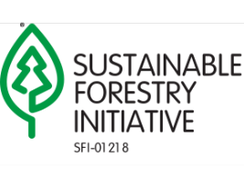
KENORA FOREST
SPECIES AT RISK INDEX CARD 2026-2027
For a complete listing of Species at Risk in Ontario, please refer to: https://www.ontario.ca/page/species-risk-ontario
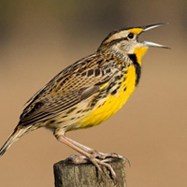    Eastern Meadowlark  Features: The Eastern Meadowlark is a medium-sized, migratory songbird (about 22 to 28 centimetres long) with a bright yellow throat and belly, a black "V" on its breast and white flanks with black streaks. Their backs are mainly brown with black streaks. | 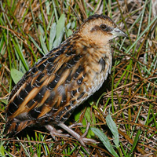  Features: The Yellow Rail is a small quail-like marsh bird, about 13 to 18 centimetres long. It has a short yellow or blackish bill and a very short tail. The chest and face are buff-yellow, and it is distinguished from other rails by the yellowish and black streaks on its back and white wing patches. It has a dark crown and dark stripe through its eyes.  Yellow Rail  SPECIAL CONCERN |  | 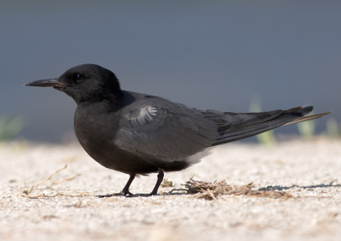  SPECIAL CONCERN  Features: Black Tern is a small tern with black head and underparts during the breeding season. They hover just above the water as they pick their prey off the surface. They build floating nests in shallow marshes, especially in cattails.  SPECIAL CONCERN  Black Tern
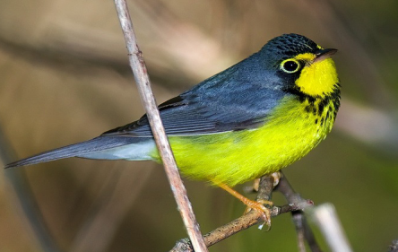  Features: Canada Warbler is a small, brightly-coloured songbird. with bluish-grey upperparts and tail, and bright yellow underparts. The head is bluish with a black forehead and ’sideburns’, which join to form a distinctive necklace of black stripes across its chest.  SPECIAL CONCERN  Canada  Warbler | 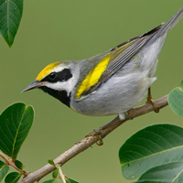  Features: The Golden-winged Warbler is a small grey songbird – about 11 centimetres long – with white undersides and distinctive yellow wing patches and forehead. Males have a black throat and black patch behind their eyes; females have the same markings in grey.  Golden-Winged Warbler  SPECIAL CONCERN |  | 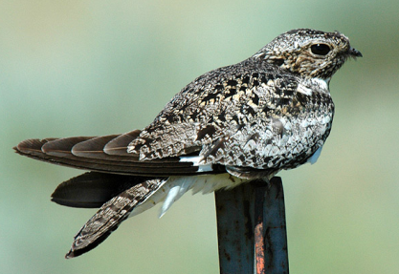  Features: Common Nighthawk is a medium-sized bird, active at night or at twilight. It has long wings, short legs, and a very short bill. It flies erratically and lives in clearcuts, burns, rock outcrops, bogs ferns, prairies, and gravel pits.  Common  Nighthawk
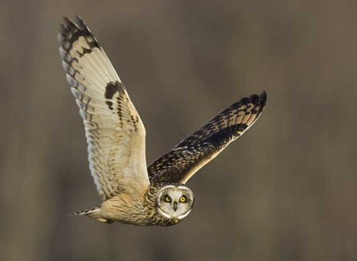  Short-Eared  Owl  THREATENED  Features: Short-eared Owl lives in open areas such as grasslands, marshes and tundra. It nests on the ground. They have relatively long wings and are often seen hunting over fields with a bouncy, butterfly-like flight. | 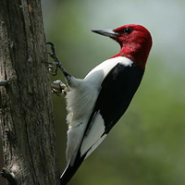  ENDANGERED  Features: The Red-headed Woodpecker is a medium-sized bird – about 20 centimetres long – easily recognized for its vivid red head, neck and breast. The rest of the bird is black and white, mostly white underneath and black on top.  Red-Headed Woodpecker |  | 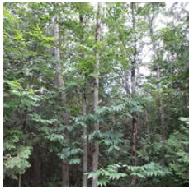  Black Ash  ENDANGERED  Features: Black Ash is a medium-sized, shade-intolerant hardwood tree species that occurs on moist to wet sites such as swamps, bogs and riparian areas.
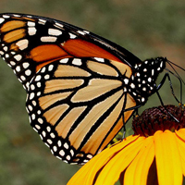  Features: The Monarch is a showy orange and black butterfly with small white spots. These butterflies are relatively large with a wingspan reaching 93-105 millimetres. The Monarch’s caterpillar is easily recognized: It has black, white and yellow stripes and can be found feeding on milkweed plants.  Monarch  Butterfly  SPECIAL CONCERN | 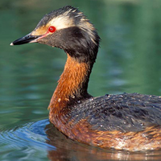  Horned Grebe  Features: The Horned Grebe is a small duck-like waterbird 31-38 cm long with a short, pointed bill. In breeding plumage, the Horned Grebe has a black head with a distinctive patch of golden yellow feathers behind its eye called “horns.” The front of its neck and upper breast are reddish. Males and females look similar, although males are typically brighter than females in breeding plumage.  SPECIAL CONCERN |  | 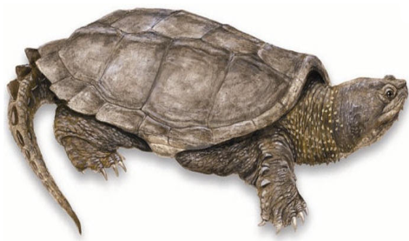  THREATENED  Snapping  Turtle  SPECIAL CONCERN  Features: Snapping Turtle reach a length of 20-36 cm. They have large black, olive or brown shells typically covered in algae. Their tails, which can be longer than their body, have “dinosaur-like” triangular crests along their length.
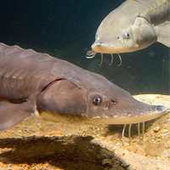  Features: The Lake Sturgeon is Canada’s largest freshwater fish, weighing up to 180 kilograms and reaching over two metres long. It has an extended snout with four whisker-like organs hanging near the mouth. Its body is covered with large bony plates, pronounced in juveniles but less pronounced in larger fishes. It is dark to light brown or grey on its back and sides with a lighter belly.  Lake Sturgeon  THREATENED | 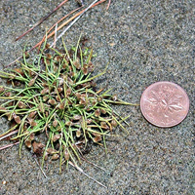  SPECIAL CONCERN  Features: The Small-flowered lipocarpha is a tiny annual sedge that grows in dense clumps. Its curved stems are up to 20 centimetres long and 0.5 millimetres wide with very narrow leaves. Small flowers are tightly clustered in dense oval spikes near the top of the stem. Tiny, dry seeds are brown with bluish highlights.  Small Flowered Lipocarpha  THREATENED |  | 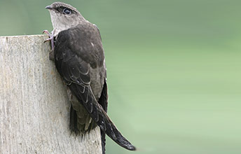  SPECIAL CONCERN  Features: The Chimney Swift is a relatively small bird, about 12 to 14 centimetres long, with a sooty brown, cigar-shaped body, long slender wings and a lighter throat. It can be distinguished by its telltale acrobatic and erratic flight pattern. The Chimney Swift spends most of its time flying and even forages in the air, catching its prey (flying insects) in flight.  Chimney  Swift
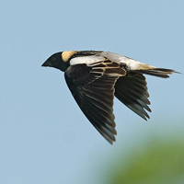  Features: The Bobolink is a medium sized songbird found in grasslands and hayfields. In their summer breeding season, male Bobolinks are black with a white back and yellow collar. By late summer, males lose their breeding plumage to resemble the female’s tan colour with black stripes.  Bobolink  THREATENED | 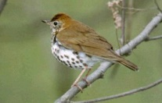  Features: The wood thrush is a medium-sized songbird, about 20 cm long – slightly smaller than the American robin and similar in shape. These birds are generally rusty-brown on the upper parts with white under parts and large blackish spots on the breast and sides.  Wood  Thrush | Features: The Eastern Meadowlark is a medium-sized, migratory songbird (about 22 to 28 centimetres long) with a bright yellow throat and belly, a black "V" on its breast and white flanks with black streaks. Their backs are mainly brown with black streaks.  Eastern Meadowlark | 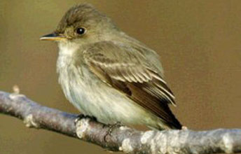  Features: The eastern wood-pewee is a small forest bird that grows to about 15 cm long. Adults are generally greyish-olive on their upper parts and pale on the under parts with pale bars on their wings. Males and females are similar in appearance. The eastern wood-pewee has a distinctive, clear, three-part song, usually recorded as “pee-ah-wee.”  Eastern  Wood-Pewee
REPORT ANY SIGHTINGS OF THESE SPECIES TO YOUR SUPERVISOR

